**File Handling**

File handling in Python refers to the process of creating, opening, reading, writing, appending, and managing files on the disk.

**File Operations**

**1.open a file:** To perform any operations on file we need open a file

Syntax:file=open(“filename.txt”,mode)

**2.reading a file:**Used to read the contents in the file**.**

**syntax:** file=open(“filename.txt”,”r”)

example:

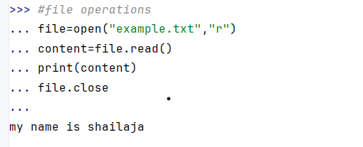

**3.writing to a file:**Write the contents into the file

file=open(“filename.txt”,”w”)

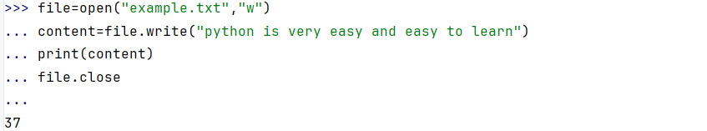

**4. appending to a file:**It is used to write the content into the file without overwriting the existing file

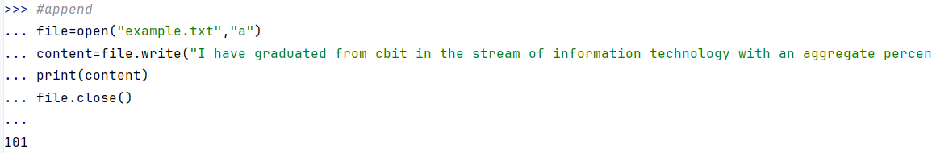

**5.closing a file:**

After completion of all operations, the file should be properly closed

Syntax:file.close()

**6. checking whether the file exists or not:**Checking os modules to check whether files exist or not

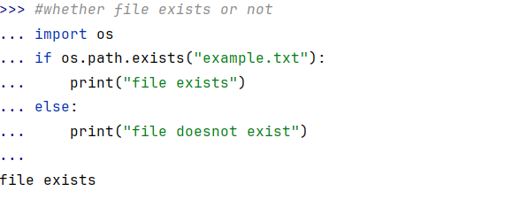

**Differnce between read() and readlines()**

**1.read():**Reads the entire file content as a single string

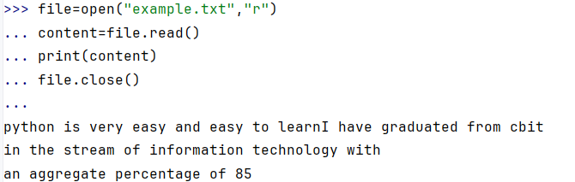

**2.readlines():**Reads all the lines in the file and returns them as a list of strings.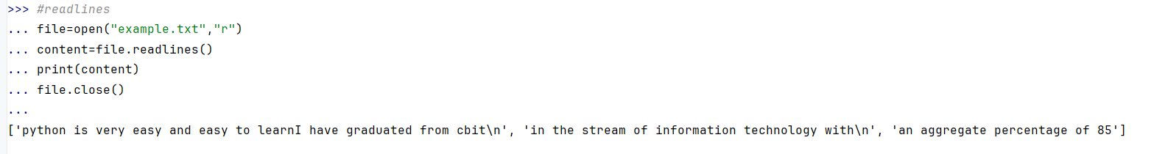

**Advantages**

1. **Versality:** We can perform a wide range of operations like creating, modifying, closing, etc.

**2. Flexibility:** It allows you to work with different files like text, binary, and CSV files.

**3. User-Friendly**:It has a user-friendly interface and allows you to work easily.

**4. Cross Platform:** Works across multiple macros, Linux, and windows platforms.

**Disadvantages**

**Error-prone:** File operations are prone to errors such as FileNotFoundError

**2. Security Risks:** It poses security risks that may contain sensitive data

**3. Complexity:**Complex when working with large advanced files

**4. Performance:** Files are slower than other programming languages

**Assignment Questions**

**1.Write a Python program to print your name 100 times**

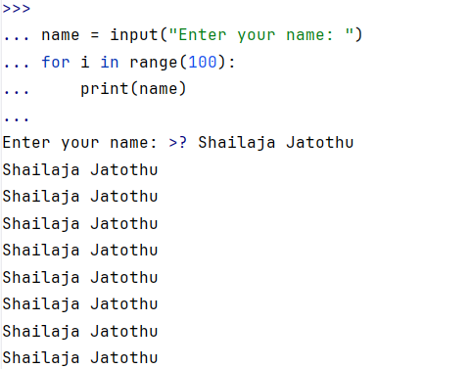

1. **W.A.P to check whether a number is even or odd**

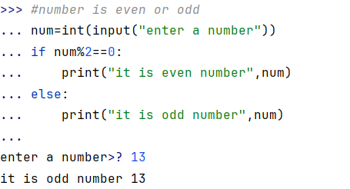

1. **W.A.P to print 7th table**

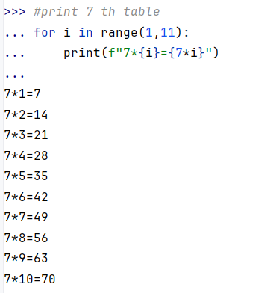

1. **W.A.P to compare to variables and print which is maximum and minimum**

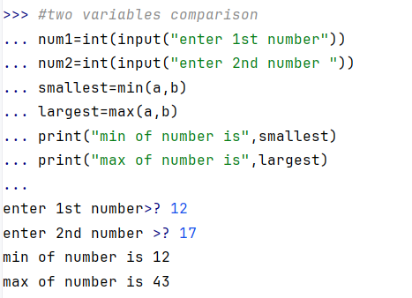

**5. W.A.P to find the largest of 3 numbers**

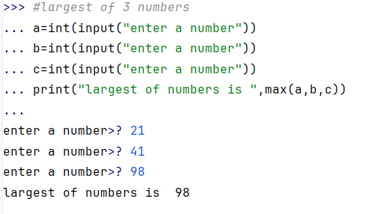

**2. Assignment**

**1. Create a list**

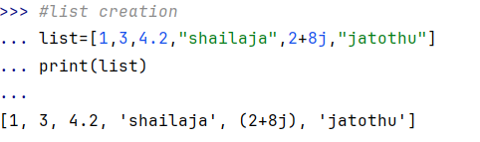

**2.access the elements in the list**

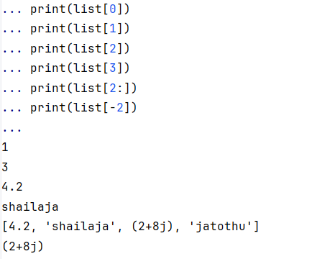

1. **change the list of items by replacing**

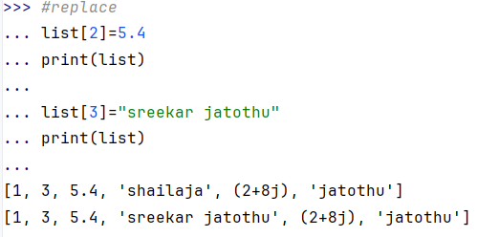

1. **perform append operation**
2. 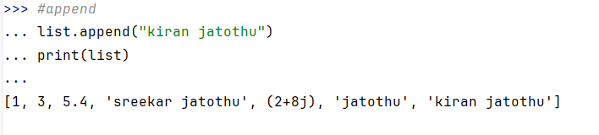
3. **insert new items into the list**

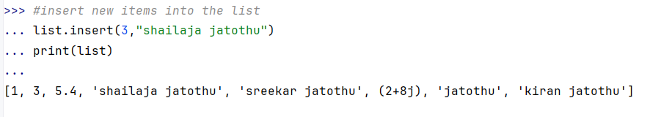

1. **extend items into the list**

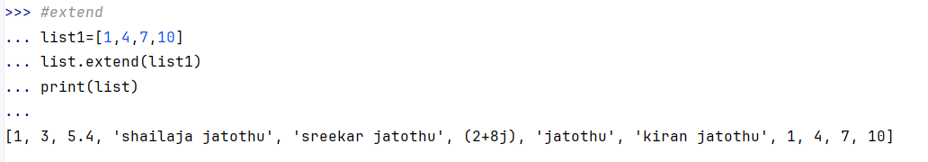

1. **remove the items from the list**

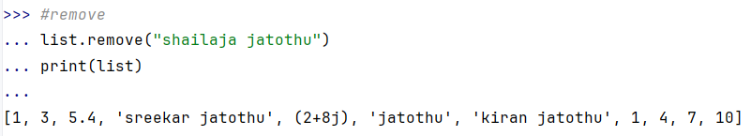

1. **clear the entire list**

